**Data Manipulation and Cleaning work**

**Account Table**

1. Convert the Date attribute into a yyyy-mm-dd by adding **24** in year format in Excel or SQL

* 1993 -> 2017
* 1994 -> 2018
* 1995 -> 2019
* 1996 -> 2020
* 1997 -> 2021

1. Replace in frequency attribute “POPLATEK MESICNE” AS **Monthly Issuance**, “POPLATEKTYDNE” AS **Weekly Issuance,** and “POPLATEK POBRATU” AS I**ssuance After a Transaction** in Excel or create a case statement in SQL.
2. Create a Custom Column Card_Assigned and assign below :

* Silver -> Monthly issuance
* Diamond - weekly issuance
* Gold - Issuance after a transaction

**CARD Table**

1. Replace type attribute value “junior” as Sliver, “Classic” as Gold,

And “Gold” as Diamond by using replace in Excel or by using update in SQL.

1. Convert issued attribute into yyyy-mm-dd adding 23 in year.

**CLIENT Table**

1. Convert bith_number attribute to yyyy-mm-dd format and also create another column named sex by applying in bith_number 0 for females and 1 for males.

**(=if(mod(bith_number,2)=0, “Female”, “Male”)** in excel or using case statement in SQL.

For **Male** its in **YYMMDD** format and for female it is **YYMM+50DD** for **Women**

**DISTRICT Table**

1. Change all column names and delete the attributes **a12** and

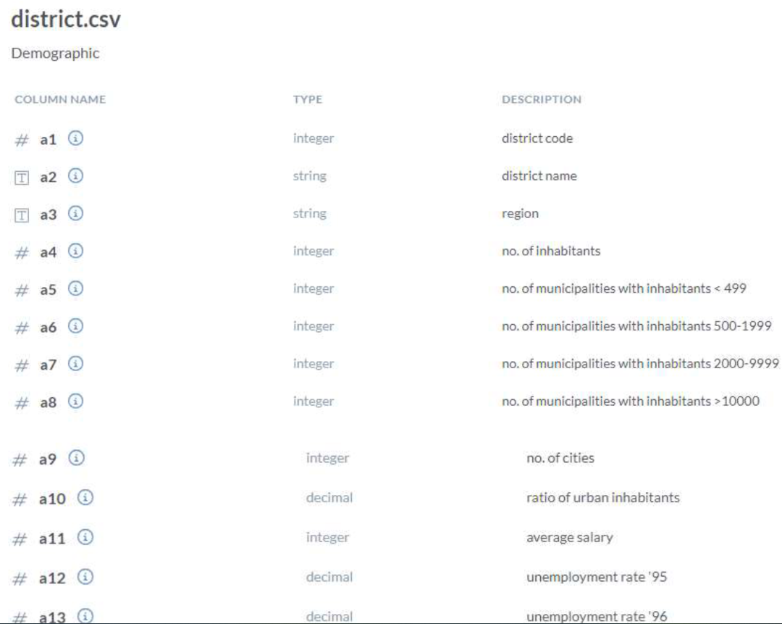

**LOAN Table**

1. Convert the Date Attribute into yyyy-mm-dd format adding 23 in year.
2. Convert Status Attribute value “A” as Contract Finished, “B” as Loan Not Paid, “C” as Running Contract, and “D” Client in debt.

In th Transactions Table do the following , whosoever count is highest sort it in descending order and change the year from 2022,2021,2020 and so on

--DATA TRANSFORMATION

/*

2021 -> 2017

2020 -> 2018

2019 -> 2019 -- NO CHANGE

2018 -> 2020

2017 -> 2021

2016 -> 2022

UPDATE TRANSACTIONS

SET BANK = 'Sky Bank' WHERE BANK IS NULL AND YEAR(DATE) = 2022;

UPDATE TRANSACTIONS

SET BANK = 'DBS Bank' WHERE BANK IS NULL AND YEAR(DATE) = 2021;

UPDATE TRANSACTIONS

SET BANK = 'Northern Bank' WHERE BANK IS NULL AND YEAR(DATE) = 2019;

UPDATE TRANSACTIONS

SET BANK = 'Southern Bank' WHERE BANK IS NULL AND YEAR(DATE) = 2018;